 | ELEC 205  Assignment 1  Gate-Level Minimization and Design
 | Deadline: April 8, 11:59 PM
 | Name and Surname: Ahmet Buğra Ertürk
 | ID: 86877
Question 1
F (A, B, C, D) = $\prod{\left(1,3,5,6,9,11,12,14\right)}$ implies F (A, B, C, D) = $\sum{\left(0,2,4,7,8,10,13,15\right)}$ since maxterm is inverse of minterm and F’ (A, B, C, D) = $∏\left(0,2,4,7,8,10,13,15\right)$ so (F’(A,B,C,D))’ = F(A,B,C,D) = $\sum{\left(0,2,4,7,8,10,13,15\right)}$. Then I filled the truth table in Figure 1 with minterms. And Logisim created the K-Map in Figure 2.

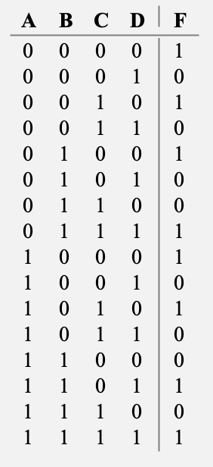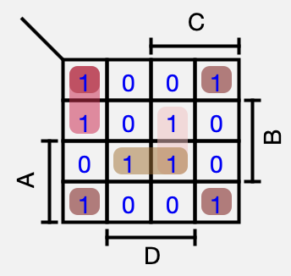
Figure 2
Figure 1

Logisim built the circuit in Figure 3 as well. Also, it gave a simplified version of F as F(A,B,C,D) = B’⋅D’+A’⋅C’⋅D’+B⋅C⋅D+A⋅B⋅D.
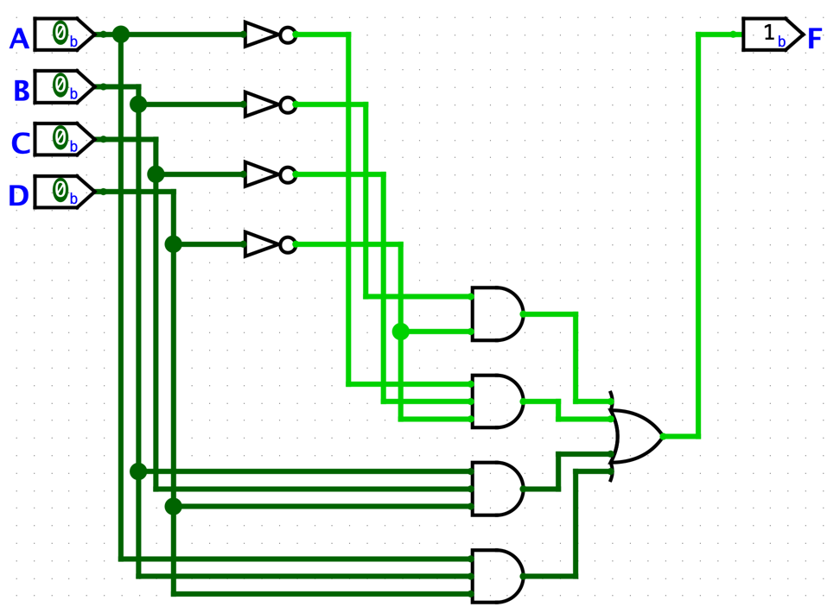
Figure 3

Question 2

- F (A, B, C, D) = ACD′ + C′D + AB′ + ABCD
First, I built the circuit in Figure 4 with using AND, OR, and NOT gate. These AND gates represent AB′, ACD′, C′D, and ABCD respectively from up to down.

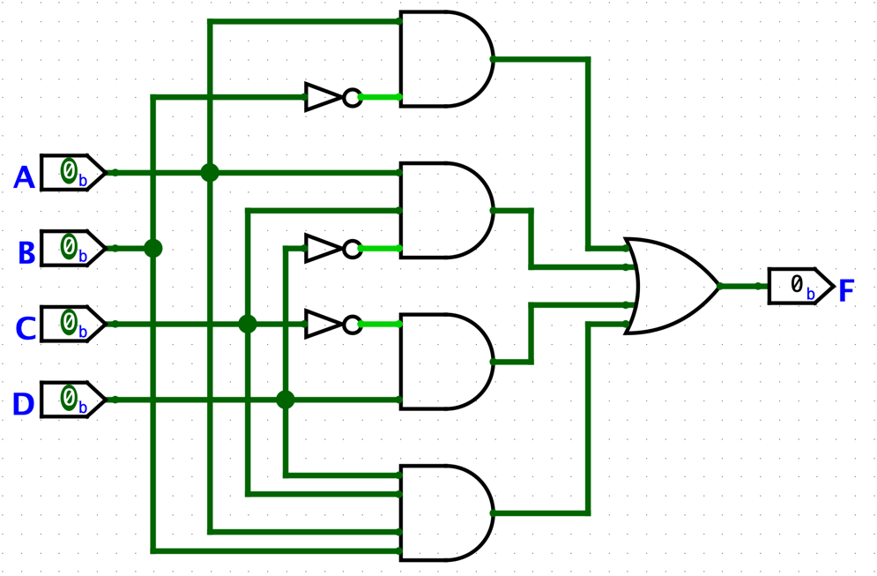
Figure 4

Then, Analyze Circuit provided this truth table (Figure 5) and K-Map (Figure 6).

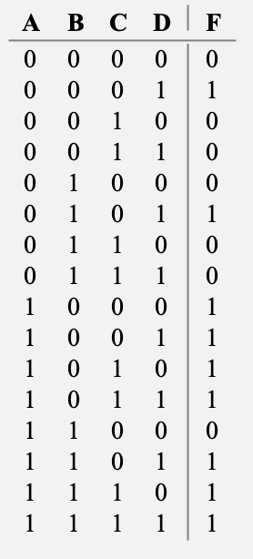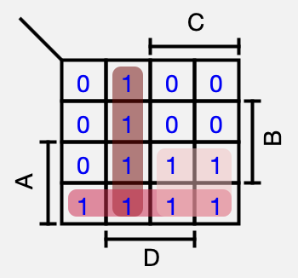
Figure 6
Figure 5

Also, it gave the simplified forms as SoP and PoS. Its SoP representation is F(A,B,C,D) = C’⋅D + A⋅B’+A⋅C, its PoS representation is F(A,B,C,D) = (A+D) ⋅ (A+C’) ⋅ (B’+C+D).

- F (A, B, C, D) = (A′ + B + D′) ⋅ (A′ + B′ + C′) ⋅ (A′ + B′ + C) ⋅ (B′ + C + D′)

First, I built the circuit in Figure 7 with using AND, OR, and NOT gate. These OR gates represent (A′ + B + D′), (A′ + B′ + C′), (A′ + B′ + C), and (B′ + C + D′) respectively from up to down.

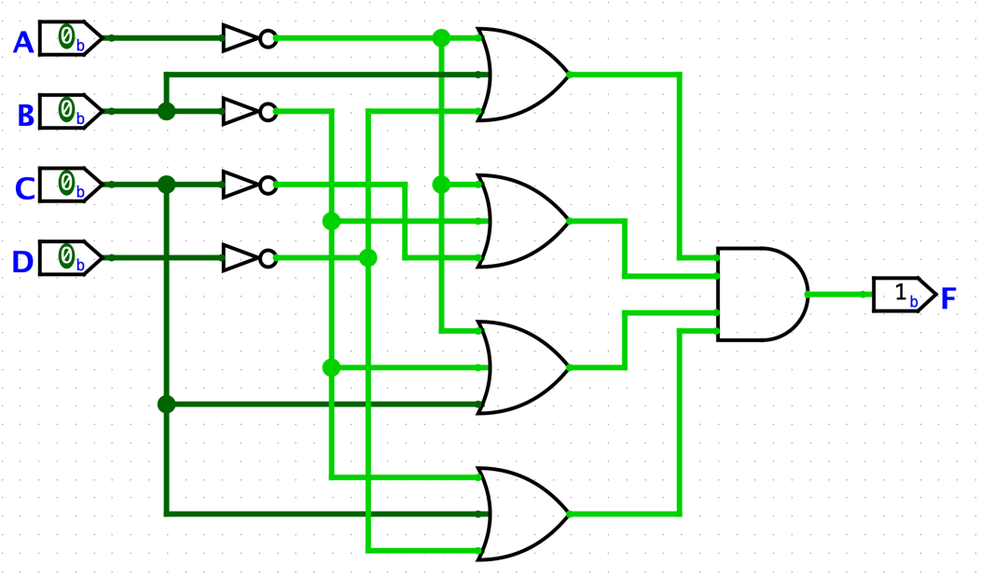
Figure 7

Then, Analyze Circuit provided this truth table (Figure 8) and K-Map (Figure 9).

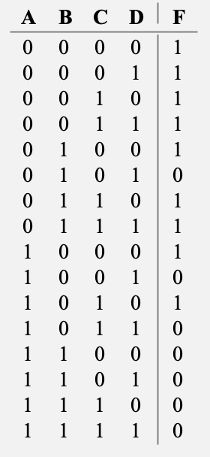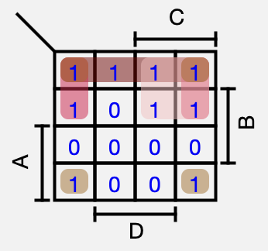
Figure 8
Figure 9

Also, it gave the simplified forms as SoP and PoS. Its SoP representation is F(A,B,C,D) = A’⋅B’+A’⋅D’+A’⋅C+ B’⋅D’, its PoS representation is F(A,B,C,D) = (B’+C+D’) ⋅ (A’+D’) ⋅ (A’+B’).

Question 3

F = BCD + ACD + ABD implies F’ = (BCD)’ ⋅ (ACD)’ ⋅ (ABD)’ and
(F’)’ = ((BCD)’⋅(ACD)’⋅(ABD)’)’, so F = ((BCD)’⋅(ACD)’⋅(ABD)’)’. Logisim built its circuit in Figure 10.

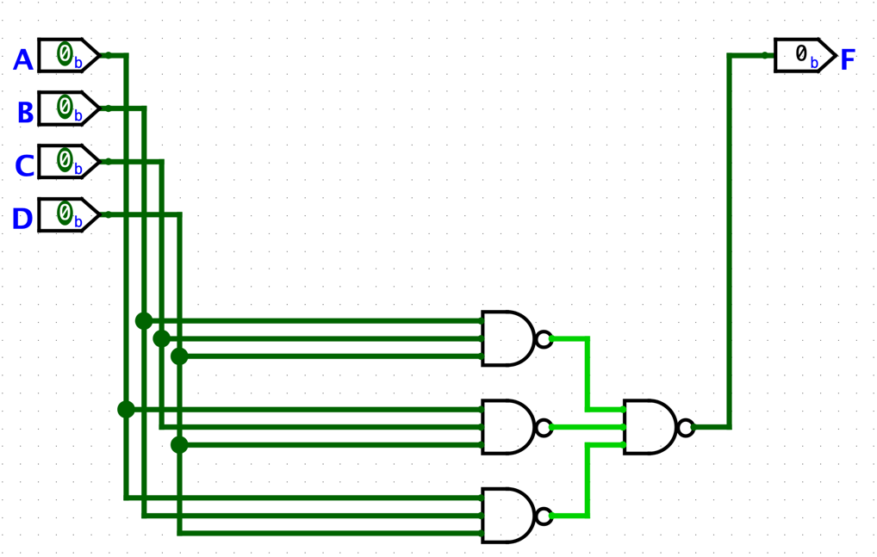
Figure 10

- Its K-Map representation is in Figure 11.

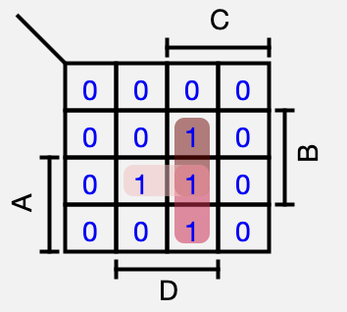
Figure 11

- Implement another circuit in the same page by converting all the gates to NOR gates (you can use additional inverters) and label the output of the new circuit as ’G’.

F = ((BCD)’⋅(ACD)’⋅(ABD)’)’ was found at the beginning. Now apply De Morgan rule, then F = (BCD)+(ACD)+(ABD). Now, for all product apply two times negation with only one De Morgan, then F = (B’+C’+D’)’+(A’+C’+D’)’+(A’+B’+D’)’. Finally, to use NOR gate perform negation two times to F and the final expression is (F’)’ = F = G = (((B’+C’+D’)’+(A’+C’+D’)’+(A’+B’+D’)’)’)’. The circuit is given in Figure 12.

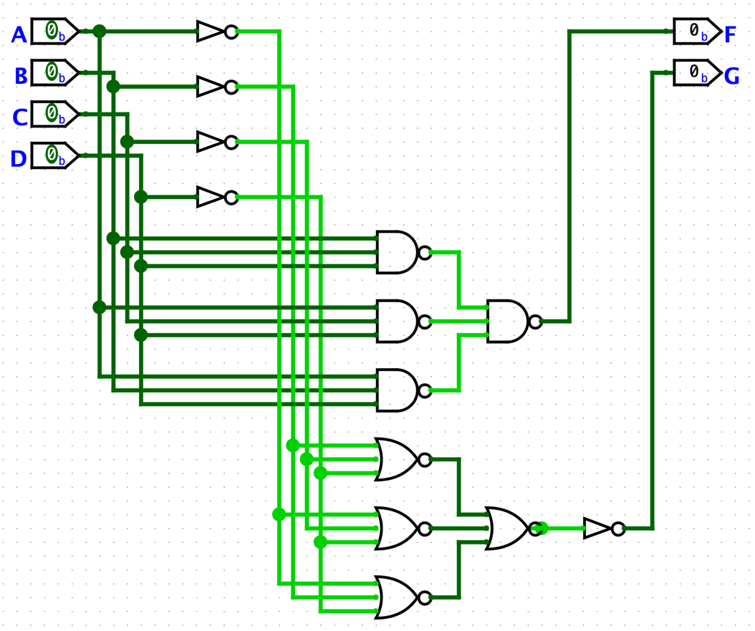
Figure 12

- Observe the outputs F and G are the same by changing the inputs A, B, C, and D.

This timing diagram in Figure 13 shows the truth values of F and G at the last two lines for corresponding A, B, C, and D values in the timing diagram. Last two lines are the totally same and it implies the outputs F and G are the same.

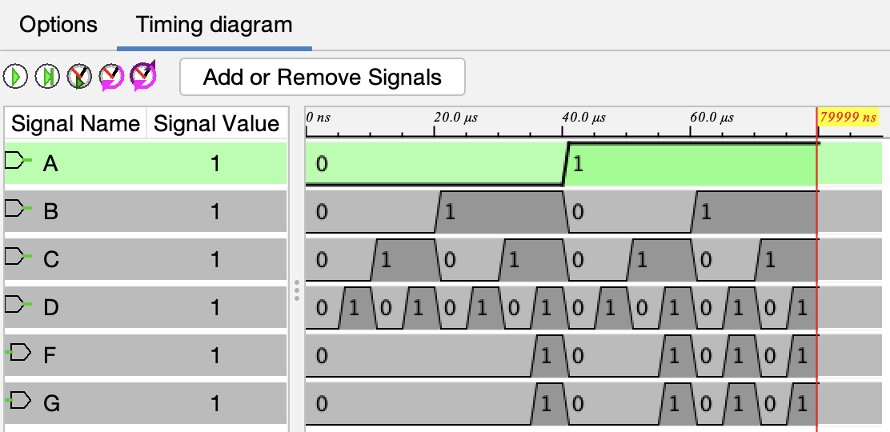
Figure 13

- Check the corresponding Karnaugh maps for F and G and show them they are the same.

Figure 14 shows K-Map for F and Figure 15 shows K-Map for G. As shown, both are the same.

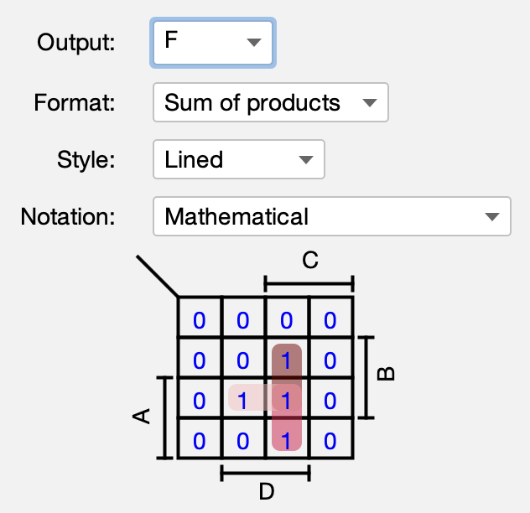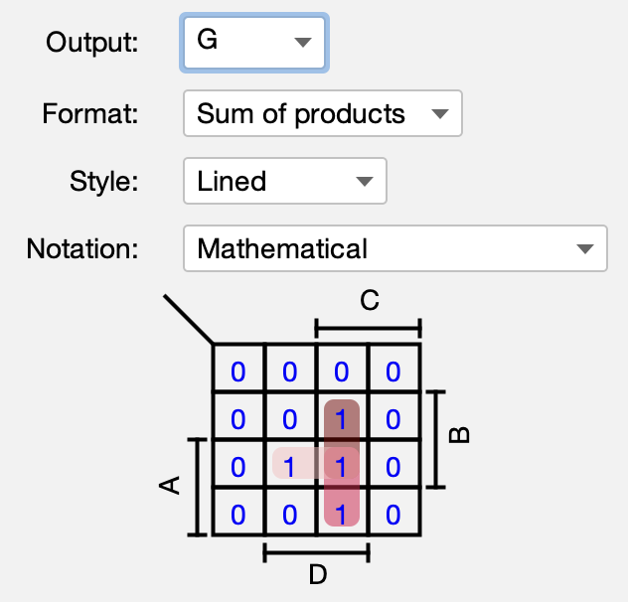
Figure 15
Figure 14

Design Problem

I used 4 1-bit input instead of 2 2-bit input. First, I filled the truth table in Figure 16 and clicked Build Circuit in Logisim. Then Logisim create the circuit in Figure 17.

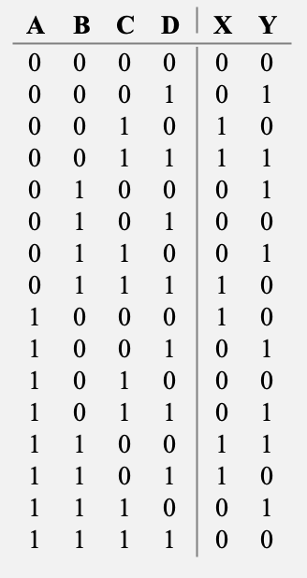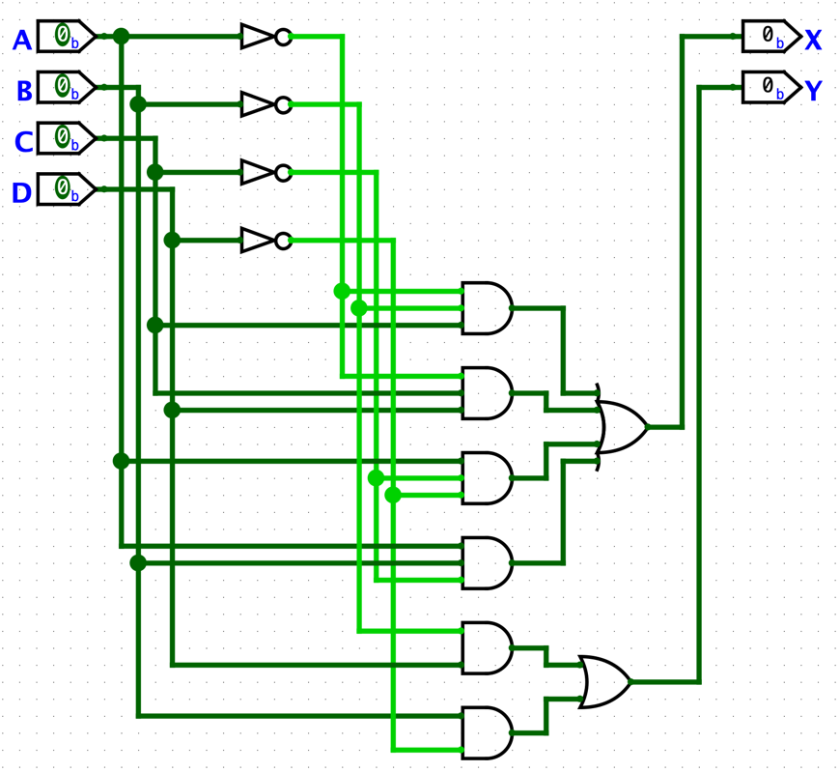
Figure 16
Figure 17

Also, Logisim provide us K-Maps in Figure 18 and Figure 19 and the output functions as
X = A’⋅B’⋅C+A’⋅C⋅D+A⋅C’⋅D’+A⋅B⋅C’ and Y = B’⋅D+B⋅D’.

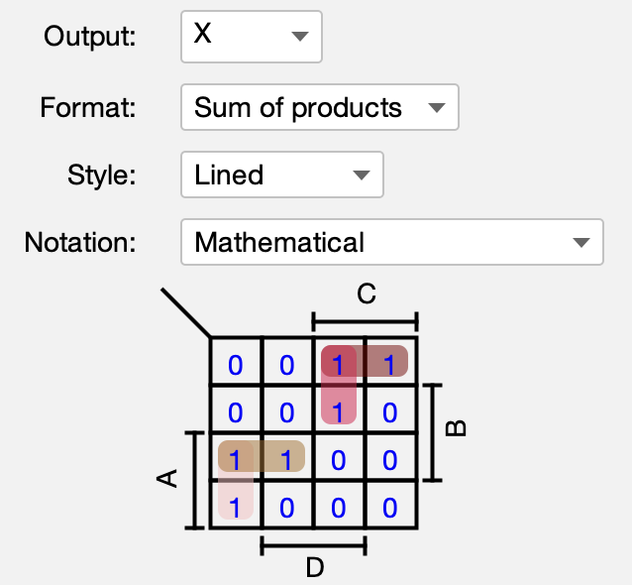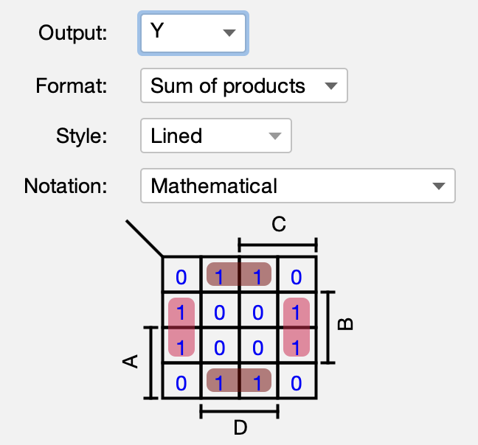
Figure 18
Figure 19

Its timing diagram is in Figure 20 and its outputs are correct since it is the same as the values in the truth table in Figure 16.

